TC-PM-005
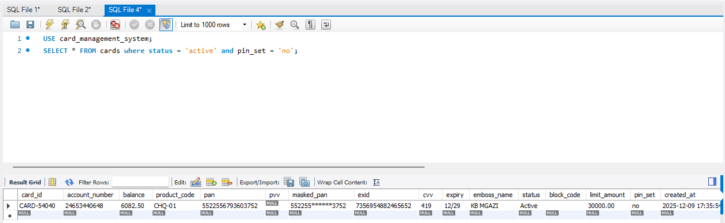
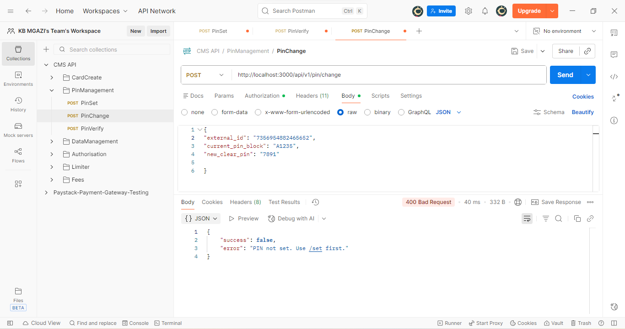
Request:
{
"external_id": "7356954882465652",
"current_pin_block": "A1235",
"new_clear_pin": "7891"

}
Response:
{
"success": false,
"error": "PIN not set. Use /set first."
}

